***Following Steps to be done for Executing the ECI Reminder Program***

1. First it will take the business partner whose U_FilingReminder = ‘YES’ and the Financial Year End also taken from the field U_YearEnd and loop it to send the email.
2. The Program will run and if the current date matches the reminder sending date (Financial Year end + 10 days), then it will send the First Email reminder to the contact person.
3. The Program will run and if the current date matches the reminder sending date (Financial Year end + 60 days), then it will send the Second Email reminder to the contact person.
4. Once the email is send out, we will maintain the email send log in following table

“[@EMAILLOG_ECI]”



1. Every time if the program runs, we are checking the email log table. If the email already sent, we are not sending one more time.
2. The Email template is stored in the program Folder “Email Template”. IF you want to change the email content, you can go and change it in the Email Template 1 and 2

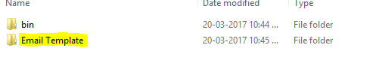

1. If the email program got any error while sending , we are grouping the email contents and send to Email id which we configured in the configuration file as below and Error email subject also configured as below

File Name: SOA_ECIFilingReminder.exe.config in the bin folder

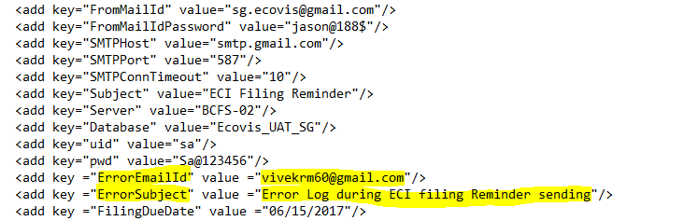

1. ECI Filing Due date also configured in the config file in the bin folder “SOA_ECIFilingReminder.exe.config”. The date format is MM/dd/YYYY



1. You can run the exe program which is in the bin / debug folder in the name of “SOA_ECIFilingReminder.exe”
2. Before running the exe, you can change all the configuration details as you needed which is under the bin/debug folder.